Evidence Output

T015:

Valid postal code case.

Input 81500 in postal code case.

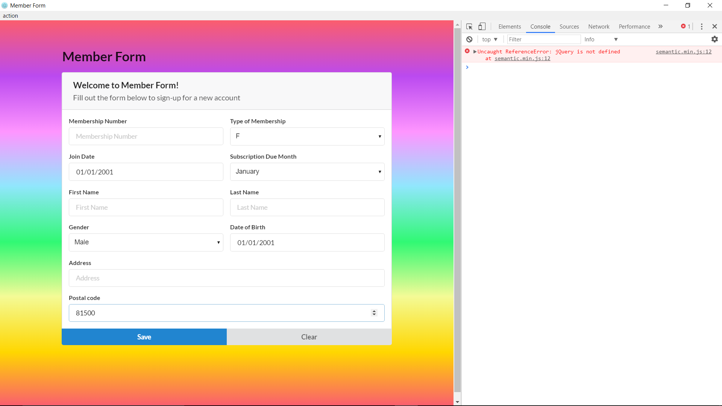

Valid postal code case success.

